Research Strategy:
Significance: Uncontrolled asthma in school-aged children is the primary medical reason that children miss school, limiting educational attainment. ¹⁻³ Since children spend many of their weekdays in school, where asthma triggers are common, appropriate school-based asthma management is necessary to de-escalate asthma flares, evaluate asthma self-management, and encourage appropriate clinician follow-up.⁴ However, many schools struggle to collect appropriate diagnostic and management paperwork or back-up medications to be stored at school, and may even be unaware a child has asthma until they are experiencing emergency symptoms. Further, many schools lack the staff or resources to implement school health initiatives.⁵⁻⁶
Chicago schools alone reported 3,603 asthma-related EMS visits to schools for asthma from 2016-2021.⁷ State-level health policy initiatives require schools to develop an asthma emergency plan, but this was only available to 60% of nurses in one survey.⁸ Stock inhaler programming, which allows for an undesignated reliever asthma inhaler to be administered by any trained school personnel, creates a failsafe for children with asthma experiencing symptoms at school.⁹ Laws to allow stock inhaler programming have been passed by 25 states.¹⁰ Due to limited program uptake after modifying their undesignated medications law to include stock inhalers in 2018, Illinois began providing statewide funding for stock inhaler programming (using the reliever albuterol) through the RESCUE-IL program in the 2023-2024 school year.¹¹ Funding is renewed annually.
The Illinois State Board of Education (ISBE) reported 1,900 events in 2023-2024 and 4,640 events in 2024-2025.^{13,14} State reporting for 2025-2026 will be available in Fall 2026 but does not include disposition. Many schools receive training, protocols, handbooks, and supplies (e.g. albuterol, disposable spacers and reusable plastic spacers) from RESCUE-IL, which serves 4,053 traditional public K-12 schools across Illinois (IL). Stock inhaler utilization events reported to RESCUE-IL have increased from 675 in 2023-2024 to 2,729 in 2024-2025 and 3,220 in 2025-2026. These discrepancies represent schools reporting to one place, but not the other and because state funding does not include private schools. Of all students who have received RESCUE-IL provided stock medication, 5,219 (80.8%) returned to class, 1,117 (17.3%) went home/other location, and only 108 (1.7%) required 911 transport for asthma symptoms (A. Volerman and A. Knitter, unpublished manuscript, 2026).^{11,12} Given that prior to stock inhaler laws, Asthma Emergency Protocols, required by PAXXX, within districts often required 911 calls to schools for any respiratory distress event, these results are promising.
The IL stock albuterol program allowed over 80% of children to return to class after respiratory distress incidents. However, albuterol is no longer the preferred treatment for acute asthma symptoms. Per guidelines from the National Asthma Education and Prevention Program (NAEPP) in December 2020 and Global Initiative for Asthma (GINA) recommendations since 2019, albuterol alone is associated with greater mortality compared to either an inhaled corticosteroid (ICS) combined with formoterol (ICS/formoterol) or an inhaled corticosteroid combined with albuterol (ICS/albuterol).^{15,16} These medications can be used as needed only (ICS/formoterol or ICS/albuterol), or as maintenance inhalers (ICS/formoterol, nicknamed “MART” maintenance and reliever therapy)). The anti-inflammatory agent of the ICS augments the relieving ability of the beta-agonist. This management approach is referred to officially as anti-inflammatory reliever therapy (AIR).¹⁷
No stock inhaler program in the US currently utilizes the AIR approach to de-escalate asthma symptoms in schools. AIR therapy is slow to penetrate into clinical practice due to insurance issues, previous use of ICS-formoterol initially as a maintenance inhaler, lack of current US pediatric indication for ICS-albuterol (although ACADIA study will likely secure FDA approval for over 12 years in 2027), hesitance of families and clinicians to change, electronic medical record template and difficulty with incorporation of new approaches into asthma action plans (AAPs), among other reasons.¹⁸⁻²³ Further, there have been limited studies regarding acceptance of AIR by school staff, but those that do exist suggest that MART therapy is well received.²⁴ School-based studies in Massachusetts demonstrated that directly observed maintenance therapy with ICS alone and/or ICS/LABA was well accepted, feasible, and improved asthma control.²⁵⁻²⁸
AIR must be incorporated into every facet of the lives of children with asthma.²⁹ The only way to improve the uptake of this “new” approach toward asthma management is to normalize it for students, families, schools, nurses, and clinicians, embracing the socio-ecological model to address a desired health behavioral change.³⁰⁻³¹ However, AIR represents a paradigm shift in asthma treatment. Instead of using ICS-containing inhalers for daily maintenance only, we now recommend it both for daily maintenance and as needed for symptoms. We cannot reasonably expect families and clinicians to immediately embrace this approach on a large scale, as has been shown in mixed methods research of clinicians that change is moving toward AIR, but slowly.^{23, 32-33} This slow uptake of an evidence-based practice shown to be superior to an accepted approach requires a multi-faceted implementation-science driven approach to address uptake.
While our colleagues work toward improved AIR incorporation in clinical settings, our team’s established access to public schools participating in statewide stock inhaler program provides a unique opportunity to educate and upscale AIR therapy to large populations of children with asthma. Our assembled team are experts in community-engaged implementation science research.³⁴⁻³⁶ We have worked with schools, lung health groups, multi-disciplinary professional organizations, school administrators, parent-teacher organizations, and government for over a decade on improving school-based asthma management.
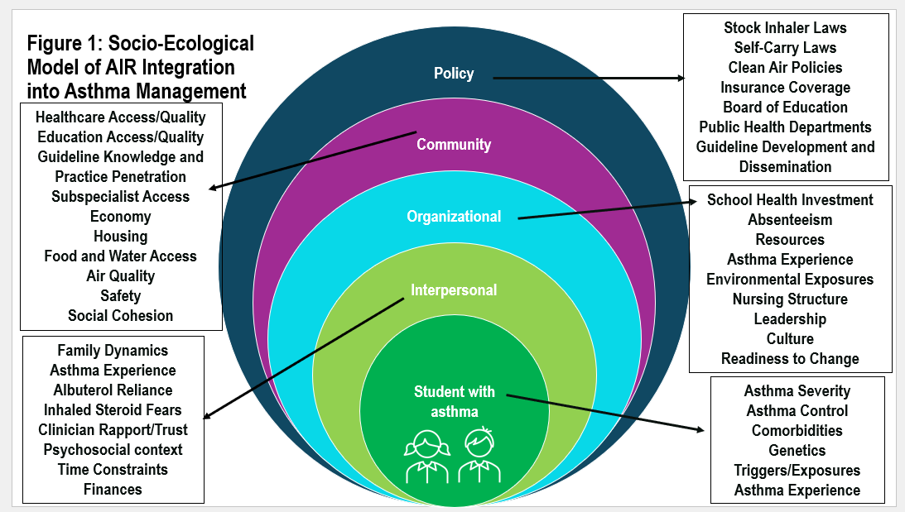
To address the lack of evidence-based AIR therapy in stock inhaler programming, we will apply an explanatory mixed methods design to assess acceptability, feasibility, baseline knowledge, barriers, facilitators, and perceptions of AIR therapy within the context of stock inhaler programming. This will lead to the development of protocols and procedures for a randomly selected group of Illinois public schools currently stocking albuterol inhalers to pilot AIR therapy within their pre-established stock inhaler program. This will be accomplished through the application of the process and determinants framework of Exploration, Preparation, Implementation and Sustainment (EPIS). ³⁷⁻⁴⁰ These principles address the context, barriers, and facilitators for which we can create multi-level levers of change (i.e., schools, families, students, clinicians). Then, proof-of-concept pilot will be employed to assess outcomes through the Reach Effectiveness Adoption Implementation and Maintenance (RE-AIM) framework.⁴¹⁻⁴⁶ The intent is to gain insights into the implementation approaches required to prepare for a future matched pair type 2 hybrid implementation trial to upscale of AIR-focused stock inhaler programming across Illinois.⁴⁷⁻⁴⁹
Innovation: This proposal is innovative in the following ways:
- This proof-of-concept study incorporates evidence-based AIR therapy into a school setting with an actively expanding and popular stock inhaler public health programming in Illinois, a state with ongoing state-funded programming in K-12 public schools.¹¹
- Making a difficult change in clinical management requires changing not only the prescribing patterns of clinicians. It requires re-education and system changes for community and families.
- The integration of community-engaged implementation science principles to infuse evidence-based AIR practices into a community school setting (opposed to a traditional clinical setting) serves as a novel, synergistic pathway to potentially improve uptake throughout pediatric asthma clinical practice through multi-directional streams of communication.^{30-31,34-36}
Approach: The main goal of this study is to assess the feasibility, acceptability, appropriateness, effectiveness, and cost of integrating AIR therapy into an established, statewide stock inhaler program that currently only uses albuterol. Aligning guideline-concordant reliever therapy into schools normalizes AIR as the standard of care, which can facilitate uptake and acceptance of these for a larger audience, including families, school staff, and clinicians receiving reports of stock inhaler events. We hypothesize that the reception of this new approach may be mixed, as clinicians demonstrate reluctance to adopt AIR despite studies consistently showing superiority to albuterol as a reliever therapy.¹⁵⁻¹⁶ Reasons for the mixed reception may be due to cost, comfort with having used albuterol for many years, and misalignment with AAPs.²¹⁻²³ Despite these hesitations, we expect to find AIR therapy’s incorporation into the IL stock inhaler program to be as effective as albuterol. This proof-of-concept study will provide the determinants and approach for a future type 2 hybrid effectiveness trial utilizing a matched pair randomization schema. This R01-level trial will compare the effectiveness (reduction of 911 calls to schools for asthma, return-to-class after event rates, along with implementation outcomes) between AIR and albuterol within statewide stock inhaler programming.
Conceptual Framework: The socio-ecological framework (SEF) is the conceptual framework that drives how to integrate AIR into stock inhaler programming and ultimately clinical practice in a way that is accepted by communities, schools, families, children, and clinicians treating asthma. The SEF’s driving theory is that change in behaviors relies on multi-level influences to be simultaneously addressed that lead to larger systemic changes that are desired whose goal is to improve health outcomes.³⁰⁻³¹ In asthma, which is fraught with health outcomes differences across socio-economic strata, working within a broader community to educate, pilot and gain acceptance through multiple partnerships is the most successful pathway to successfully integrate guideline-based care (Figure 1).^{34-36,54} Theoretical frameworks from implementation science can guide the process and determine factors critical to this proposed intervention. Namely, the EPIS Framework will be utilized to ensure that each step is thoroughly investigated prior to implementation with an ongoing process evaluation, utilizing RE-AIM to evaluate outcomes.⁴¹⁻⁴² We will use the preliminary data collected in this project to inform a type 2 hybrid implementation trial utilizing a matched-pair design and school-level cluster randomization to inform best practices for transitioning stock inhaler programs to AIR.⁴⁷⁻⁵³ Figure 2 presents the logic model of how we will answer our research question through these Aims.
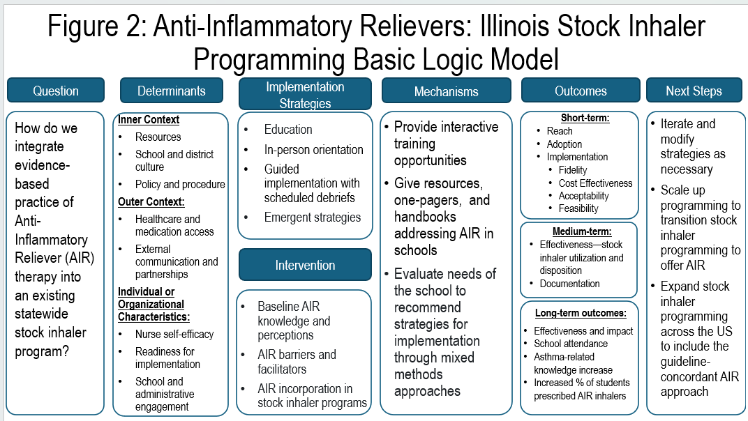
Project Team: This project PI is an allergist-immunologist for adults and children with indefinite tenure at the state’s public university system, University of IL/UI Health. Her research expertise is in school and community-based public health interventions that utilize community-engaged implementation science methods. She aims to infuse evidence-based practice into the everyday lives of children and adults with asthma and allergic disease. Regularly working with multiple professional, community, environmental, lung health, governmental, legal, public health, and parental organizations, in addition to school and employees, Paige Hardy, MPH, is a Research Coordinator with skills in motivational interviewing, data management, and quantitative data analysis. She holds an MPH in epidemiology from the nationally renowned UIC School of Public Health. She has worked alongside Dr. Pappalardo for four years and has extensive experience in recruitment and retention of populations across Illinois. Rachel Lane, MS, is a biostatistician who has worked with Dr. Pappalardo for three years. Her specialty is working with public health epidemiological studies and health education research studies that span community populations. Her expertise in methods design, causal inference, and clinical trial preparation will provide the biostatistical expertise needed to execute the matched pair analysis to cluster randomize school sites in RESCUE-IL and co-create the resultant R01 trial design in the follow-up study.
Key Community Partner Collaborations: For the past decade, the PI of this study has cultivated and maintained ongoing relationships with multiple partners across the school-and community-based asthma and allergy community statewide and nationally. Specifically, she helped perform a statewide pilot of stock albuterol programming throughout Illinois in urban, rural, and suburban school districts, resulting in program expansion through the state-funded, statewide stock albuterol program.⁵⁵ The main partners with whom we work with regularly and for over a decade to address asthma health outcomes in schools include: Respiratory Health Association, Allergy, Asthma Impact and Rescue, Allergy and Asthma Foundation of America, American Lung Association, National and Illinois Association of School Nurses, Illinois Parent Teacher Association, Illinois Association of Regional Superintendents for Schools, multiple school districts across Illinois, clinicians, researchers, academic and community-based healthcare organizations, and more. Through these relationships and through the state government agency partnerships with the Illinois Department of Public Health (IDPH)’s the Illinois Asthma Partnership, the Illinois Department of Human Services, and ISBE, these partnerships ensure this program’s transition to the incorporation of AIR proposed in this research proposal.
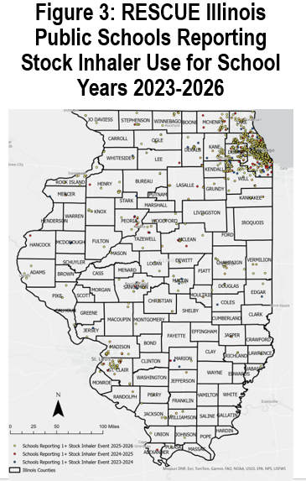
Preliminary Studies/Background: Incorporating AIR therapy into stock inhaler programming is the next logical step to embrace guideline-concordant acute asthma management practices in schools. Our research team has the necessary expertise in translating school-based asthma public health interventions to programmatic reality. When we observed fewer stock inhaler events than expected, we used ALA pilot funding to investigate and mitigate real barriers to implementation.⁵⁶ Then, we piloted stock inhaler programming in schools of various geography and resources in Illinois through the same funding mechanism across 14 schools, reaching 10,265 students.⁵⁶ In 2023-2024 SY, we began a pilot of four schools in Chicago Public Schools (CPS), the fourth largest school district in the country, resulting in program upscale to all 622 schools by the end of the Fall 2024 semester with assistance from state funding and partnerships.⁵⁷ All utilized EPIS and RE-AIM frameworks.³⁷⁻⁴² We continue to monitor outcomes (asthma and absence rate in CPS) with unpublished findings demonstrating an increase in diagnosed asthma, likely through improved documentation, and improved absence rate for those with asthma. We also worked with our RESCUE-IL partners, the IDPH, University of Chicago, and RHA to evaluate RESCUE-IL programming to date. Together, we observed high program satisfaction, identified areas of growth like protocol adherence, and adapted programming accordingly.⁵⁸. Many IL public schools, who know and trust our team, would be eligible for this proposed R03 study (Figure 3).
Aim 1: To evaluate acceptability, feasibility, barriers and facilitators of AIR therapy through a widely distributed, multi-disciplinary survey.
Study Design: This survey will examine comfort with traditional and AIR asthma management strategies, acceptability, feasibility, and appropriateness, and knowledge of the AIR approach. Aim 1 focuses on quantitative measurements through a targeted multi-sector survey approach across disciplines.
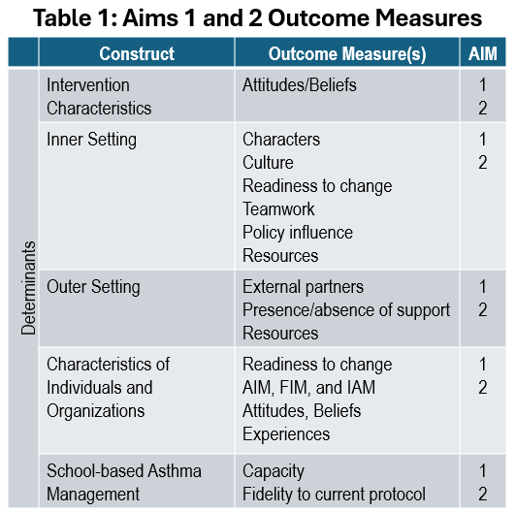
Methods: Through surveys, we will assess large-scale support and/or concern related to AIR incorporation within stock inhaler programming. We expect at least 200 responses across disciplines. A modified survey from previous stock inhaler surveys will be created, adjusted to target AIR, pilot-tested, and distributed through REDCap.⁵⁹ Each survey will be tailored to specific roles and/or organizations, including the Illinois Department of Public Health (school nurses), Illinois Principal Association or Illinois Association of Regional Superintendents of Schools (school administrators), the Illinois Asthma Partnership (lung health public health department coalition), and the Illinois Parent Teacher Association (caregivers). Clinicians will not be included in this specific study given existing literature on this topic.²²⁻²³ The survey is expected to take approximately 15 minutes to complete, and informed consent will be obtained prior to participation. Upon completion, all participants will be eligible to receive $15 in renumeration.
Acceptability, feasibility and intervention appropriateness will be evaluated through the validated Acceptability of Intervention Measure (AIM), Feasibility of Intervention Measure (FIM) and Intervention Appropriateness Measure (IAM).⁶⁰ selected relevant sub-scales of the validated Organizational Readiness to Change Assessment will be included and analyzed.⁶¹⁻⁶² Barriers and facilitators will be assessed through a mixture of checkbox and open-ended response opportunities. Respondents will be assessed on their pre-existing knowledge of AIR and their perceptions of stock AIR vs traditional albuterol stock inhaler approaches.
Analysis: Descriptive statistics will be calculated for survey questions as appropriate in R 4.6.1.⁶³⁻⁶⁴ Acceptability of Implementation, Feasibility of Intervention, and Intervention Appropriateness Measure responses will be averaged and compared across groups and compared to albuterol stock inhaler pilot pre-implementation as a relative measure.⁶⁰ Qualitative coding of open-ended survey responses will be done with at least two coders.⁶⁵ Regression models will be created to identify factors associated with comfort with AIR.
Outcomes (Table 1): The outcomes for this Aim will be acceptability (defined as an average AIM score of ≥4), feasibility (defined as an average FIM score of ≥4), intervention appropriateness (defined as an average IAM score of ≥4) along with identified barriers, facilitators, and knowledge and perceptions of AIR vs albuterol.⁶⁰
Potential Pitfalls/Alternative Approaches: Potential pitfalls include 1. If we do not reach expected participation, we will seek alternative listserv options for the less recruited populations (i.e. Chicago Asthma Consortium for caregivers/lung health organization partners, etc.). We could also attempt snowball sampling, and/or recategorize disciplines. 2. It is possible that survey will find that the incorporation of AIR is not found to be acceptable, feasible or appropriate. To address this possibility, follow-up questions will be coded into the survey design to assess if any answer is below four for either of the outcomes, and what factors would enhance acceptability, feasibility or appropriateness to ascertain if the hesitation is modifiable. 3. Perceptions or attitudes toward this therapy may reveal a lack of readiness to change. In this case, education and human-centered design approaches to frame potential solutions may be warranted before full roll out but should not prevent pilot from moving forward. 4. Discordance among respondents with some more ready or willing than others may be discovered. This presents an opportunity to address this discrepancy through partners working together to expand acceptance of AIR. 5. Response bias, with respondents who are more familiar with or accepting AIR being more likely to complete the survey, will be noted as a limitation.
Aim 2: To evaluate acceptability, feasibility, perceptions, barriers and facilitators of AIR therapy within stock inhaler programming through semi-structured qualitative interviews.
Study Design: Interviews will be employed to understand perceptions of AIR, school-based school management through respiratory distress de-escalation and stock inhaler programming, barriers and facilitators to AIR therapy, and perceived acceptability to participants. We will also ascertain in more detail any follow-up issues seen within preliminary analysis of Aim 1’s survey.
Methods: Participants will be recruited for semi-structured interviews through purposive and random sampling methods. Aim 1 survey respondents will be able to indicate whether they are interested in participating in a follow-up interview. An additional recruitment email and flyer for the interviews will be sent to each of the above listservs. We anticipate about 50 participants in total, with approximately even distribution among respondent types (i.e., school health staff/nurses, administrators, caregivers, and lung health organizations). Informed verbal consent will be obtained prior to interview initiation. An interview guide will be modified from previous stock inhaler projects to incorporate AIR and additional perception questions. A trained and experienced qualitative interviewer will conduct the audio-recorded semi-structured interviews virtually or in-person.⁶⁶ Interviews will last about 30 minutes, and re-numeration of $25 offered. Initial Zoom transcripts will be reviewed, corrected, and de-identified in preparation for analysis. COREQ principles will be incorporated.⁶⁷
Analysis: All de-identified transcripts will be uploaded into the qualitative data analysis software, Dedoose.⁶⁸ The analysis will start with the initial structure of grounded theory, but then allow for a combined deductive and inductive (abductive) approach to codebook thematic analysis as it progresses.⁶⁹⁻⁷³ A codebook will be created based on EPIS constructs (i.e.., acceptability/feasibility, barriers/facilitators, adopter/decision maker characteristics, awareness, champions, etc.)⁷⁴ Memoing will be completed for each interview to summarize and structure initial reflections within analysis and determine progress toward enough information to appropriately analyze the data.⁷⁵ Then, the coding team will iterate the codebook through a series of transcript reviews until the codebook is finalized and congruence within the coding team achieved. Interrater agreement will be calculated for the remaining transcripts ^{66,76.} Code summaries and co-occurrences will be collated and analyzed, summaries reviewed, reflexivity incorporated to sort and shift data into categories, and themes will be discovered from the data that provide meaningful patterns.⁷⁷⁻⁷⁸ Comparative analyses between respondent types will be assessed. Themes will help us to Prepare for Implementation (EPIS) in the Aim 3 pilot.^{65,77}
Outcomes: The outcomes related to this Aim include identification of barriers, potential solutions to address these barriers, facilitators, and themes related to the incorporation of AIR into stock inhaler programming in schools through a variety of partner perspectives.
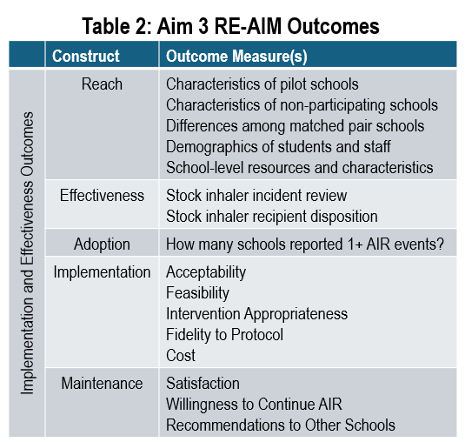
Potential Pitfalls/Alternative Approaches: Potential pitfalls include 1. If we encounter recruitment difficulty of a certain subset of individuals, further outreach will be done as described in Aim 1’s section. We will encourage snowball sampling among groups that require more participation. 2. Barriers may come up that would be difficult to modify prior to the pilot; we will work with partners to find interim and long-term solutions to address and work into the Aim 3 pilot to assess effectiveness. 3. Thematic saturation may not be reached. We feel that the sample size and diverse perspectives provided by the sample we plan to recruit is enough for the information power to create meaningful answers to our research questions that provide ample information required to start with a pilot. We do not expect all perspectives to be incorporated, or that everyone will have the same experience. 4. Differences in implementation readiness may exist, for which we will create targeted education for reluctant groups and/or other interventions to improve understanding. 5. Respondents may refuse AIR. In response, we will exempt them from the pilot and provide them with their supplied albuterol instead, provide them with AIR educational material, and reach out to local pediatricians and/or health departments to assess practice patterns and local educational opportunities.
Aim 3: To pilot an AIR stock inhaler program in Illinois public schools already participating in a statewide stock albuterol program that vary by size, organization, and geographic location to compare implementation-related components.
Study Design: This is a proof-of-concept pilot study designed to assess the feasibility and implementation components related to AIR incorporation within stock inhaler programming schools in IL.
Methods: All stock inhaler program schools with at least one utilization in the past school year will be offered participation in this proof-of-concept pilot. Based on existing results that rurality has less of an impact on stock inhaler programming, if greater than 10 schools express interest, preferential pilot schools/districts will be chosen by having higher percentage of students eligible for free or reduced meals (FRM).⁷⁹ Supplemental administrative data will be downloaded through publicly reported data from the ISBE and the IDPH. A total of 10 AIR pilot schools will be recruited.⁴³⁻⁴⁶⁾ Stock inhaler incident reports of pilot schools will be reported to the study team and compared to larger data collected through the RESCUE-IL program. Pilot schools will be supplied AIR therapy, specialized AIR administration protocol, spacers, supplies and a modified implementation handbook. Training will be conducted with a certificate. Active AIR schools will complete an in-person or virtual school walk-through and environment assessment, surveys, and interviews after consent is obtained. Scheduled de-briefs and as needed availability will be offered as implementation strategies. The AIR pilot will last at least one semester, with preferred duration of one school year.
Outcomes (Table 2): The primary outcome for Aim 3 is whether the stock AIR inhaler is utilized and resulting disposition. The RE-AIM implementation science outcomes framework will be utilized to evaluate this pilot.
Analysis: The sample will be analyzed using R.⁶⁴ Descriptive statistics will be assessed. Chi-square analysis or Fisher Exact test will be applied to assess categorial variables and any differences based on variables such as geography (locale codes), school performance (summative designation), student population characteristics, school size, grade level (elementary, middle and/or high school), among other factors.⁸¹ Stock inhaler incidents will be analyzed based on similar factors, along with setting, trigger, timing (day, season), and disposition after incident. Early comparisons with the larger albuterol-based programmatic sample will be made. AIR vs albuterol schools, and schools that utilized stock inhalers and did not utilize, compared through paired t-tests to assess for any differences among hesitance to use, use, and outcomes. Table 3 includes a project timeline.
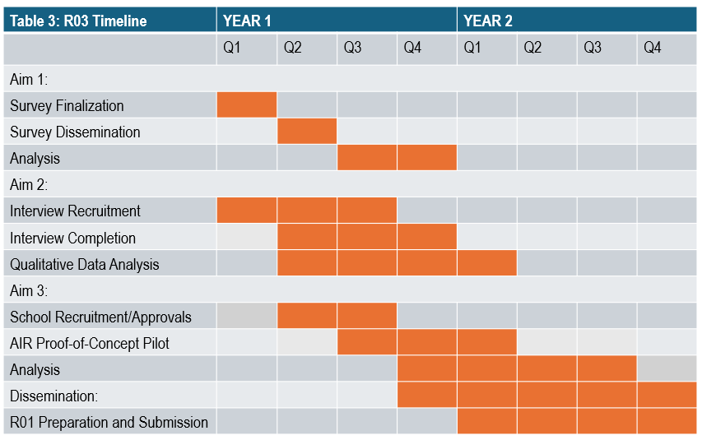
Potential Pitfalls/Alternative Approaches: Potential pitfalls include: 1. Enrolled schools are all located in the same region and/or share other characteristics. This is a proof-of-concept study, so matching characteristics at this stage is not expected, but if we find certain characteristics under-represented, this will facilitate the set-up of the R01-trial to ensure consideration of these factors. 2. Schools drop out mid-year. To address this proactively, we accommodated for this potential pitfall by accepting 10 schools into the pilot. 3. AIR unfamiliarity may raise questions among caregivers. We will provide education and materials specifically designed for caregivers and school boards and lean into our IL-PTA partnership. 4. Providers may question the use of AIR within the stock inhaler program. we will engage with them individually and provide education/resources. 5. Adverse reactions from albuterol or AIR. These are unlikely, but if they occur, we will assess the reaction, fill out an unexpected occurrence report, and ascertain the likelihood of direct relationship to the medication. Albuterol, ICS-formoterol and ICS-albuterol are safe medications, used frequently throughout the world.⁸³⁻⁸⁹ IL stock inhaler laws indemnify prescribers, schools, and trained individuals who provide any asthma medication in good faith to someone with asthma symptoms.⁹⁰ 6. ICS-formoterol is used with someone who is on an ICS-salmeterol or other LABA. Although not preferred, this is safe for one-time use, therefore we will monitor.⁸⁷ 7. An ICS-SABA combined inhaler is not approved by the FDA as a reliever by pilot initiation. ¹⁸⁻²⁰ If not approved, we will use ICS-formoterol only.
References:
- Merghani MM, Mohmmed RGA, Al-Sayaghi KM, et al. Asthma-related school absenteeism: Prevalence, disparities, and the need for comprehensive management: A systematic review and meta-analysis. Dialogues Health. 2025;7:100239. doi:10.1016/j.dialog.2025.100239
- Zahran HS, Bailey CM, Damon SA, et al. Vital Signs: Asthma in Children — United States, 2001–2016. MMWR Morb Mortal Wkly Rep. 2018;67:149–155. DOI: http://dx.doi.org/10.15585/mmwr.mm6705e1.
- Moonie S, Sterling DA, Figgs LW, et al. The Relationship Between School Absence, Academic Performance, and Asthma Status. J Sch Health. Feb 2008;78(3):140-148.
- Minier M, Hirshfield L, Ramahi R, et al. Schools and Health: An Essential Partnership for the Effective Care of Children with Chronic Conditions. J Sch Health. 2018.88(9):699-703.
- Pappalardo AA, Paulson A, Bruscato R, et al. Chicago Public School nurses examine barriers to school asthma care coordination. Public Health Nurs. 2019;36(1):36-44. doi:10.1111/phn.12574
- Edenfield K, Hingston D, Hardy P, et al. Breathing Easy: A Qualitative Analysis of School Nurse and Administrator Perspectives on Stock Inhalers and School-Based Asthma Management. J Sch Nurs. Published online January 22, 2025:10598405241311137. doi:10.1177/10598405241311137
- RHA. Racial Disparities in Childhood Asthma Chicago, 2016-2021. Respiratory Health Association; 2022. Accessed July 30, 2026. https://resphealth.org/wp-content/uploads/2022/05/Updated-Asthma-Disparities-Report.pdf
- Hardy P, Gonzalez M, Volerman A, et al. Asthma policy in Illinois: A survey of school nursing and staff knowledge and implementation patterns. Public Health Nurs. 2024;41(4):704-708. doi:10.1111/phn.13337
- Volerman A, Lowe AA, Pappalardo AA, et al. Ensuring Access to Albuterol in Schools: From Policy to Implementation. An Official ATS/AANMA/ALA/NASN Policy Statement. Am J Respir Crit Care Med. 2021;204(5):508-522.
- ALA. Asthma Medication in Schools. American Lung Association. July 7, 2025. Accessed July 30, 2026. https://www.lung.org/lung-health-diseases/lung-disease-lookup/asthma/health-professionals-educators/asthma-in-schools/asthma-medication-in-schools
- Respiratory Health Association, Asthma and Allergy Foundation of America. RESCUE Illinois Schools: 2023-2024 Report. 2024. Accessed July 31, 2026. https://www.isbe.net/Documents/Year-One-RESCUE-Report.pdf
- Knitter A, Volerman A. RESCUE Illinois: Year 2 Outcomes. Presented at: Illinois Asthma Partnership 2025 Meeting; September 24, 2025.
- Sanders T. The Administration of Undesignated Asthma Medication, School Year 2023-24. Illinois State Board of Education; 2024. Accessed July 30, 2026. https://www.ilga.gov/documents/reports/ReportsSubmitted/5237RSGAEmail11172RSGAAttachThe%20Administration%20of%20Undesignated%20Asthma%20Medication,%20School%20Year%202023-24.pdf
- Sanders T. The Administration of Undesignated Asthma Medication, School Year 2024-25. Illinois State Board of Education; 2025. Accessed July 30, 2026. https://www.ilga.gov/Documents/Reports/ReportsSubmitted/6179RSGAEmail13615RSGAAttach02.%20%20Annual%20Asthma%202025%20Report%20(FINAL%209-30-2025%20v.2).pdf
- Cloutier MM, Baptist AP, Blake KV, et al. 2020 Focused Updates to the Asthma Management Guidelines: A Report from the National Asthma Education and Prevention Program Coordinating Committee Expert Panel Working Group. J Allergy Clin Immunol. 2020;146(6):1217-1270. doi:10.1016/j.jaci.2020.10.003
- Reddel HK, Bateman ED, Becker A, et al. A summary of the new GINA strategy: a roadmap to asthma control. Eur Respir J. 2015;46(3):622-639. doi:10.1183/13993003.00853-2015
- Levy ML, Crooks MG. Anti-inflammatory reliever therapy (AIR) for asthma. ERJ Open Res. 2024;10(5):00494-2024. Published 2024 Sep 30. doi:10.1183/23120541.00494-2024
- AstraZeneca. Evaluating the efficacy and safety of PT027 compared with PT007 administered as needed in participants 12 to <18 years of age with asthma (ACADIA). ClinicalTrials.gov website. https://www.clinicaltrials.gov/study/NCT06307665
- Bacharier LB, Raissy H, Bardsley S, et al. Efficacy and safety of as-needed albuterol-budesonide versus albuterol in patients with asthma aged 12 to <18 years: design of the randomised, double-blind, parallel-group phase IIIb ACADIA trial. BMJ Open Respir Res. 2026;13(1):e003843. doi: 10.1136/bmjresp-2025-003843.
- AIRSUPRA. Prescribing information. AstraZeneca Pharmaceuticals LP; 2025.
- Zaeh SE, Zimmerman ZE, Eakin MN, et al. Adoption and implementation of maintenance and reliever therapy for adults with moderate-to-severe asthma. Ann Allergy Asthma Immunol. 2024;133(3):318-324. doi:10.1016/j.anai.2024.06.011
- Eshghi E, Ryan G, Goulding M, et al. Clinician and family perspectives on the use of single maintenance and reliever therapy for children. Ann Allergy Asthma Immunol. 2026;137(2):194-201. doi:10.1016/j.anai.2026.03.030
- Trivedi MK, Spano M, Agudelo DM, et al. Pediatric Provider Experiences With Single Maintenance and Reliever Therapy (SMART). Pediatr Pulmonol. 2026;61(3):e71542. doi:10.1002/ppul.71542
- Goulding M, Ryan G, Mejia D, et al. School Health Staff Perspectives on the Implementation of Single Maintenance and Reliever Therapy (SMART) for Children with Asthma. Pediatr Pulmonol. 2026;61(1):e71453. doi:10.1002/ppul.71453
- Gerald LB, McClure LA, Mangan JM, et al. Increasing adherence to inhaled steroid therapy among schoolchildren: randomized, controlled trial of school-based supervised asthma therapy. Pediatrics. 2009;123(2):466-474. doi:10.1542/peds.2008-0499
- Trivedi M, Spano M, Frisard C, et al. A Pilot Pragmatic Cluster Randomized Trial of School-Supervised Therapy to Improve Pediatric Asthma Control. J Allergy Clin Immunol Pract. 2025;13(11):2980-2990.e4. doi:10.1016/j.jaip.2025.07.022
- Arcoleo K, McGovern C, Allen E, et al. School-based asthma therapy: Improving medication adherence, asthma control, and health care utilization. J Allergy Clin Immunol Glob. 2025;4(2):100428. Published 2025 Jan 31. doi:10.1016/j.jacig.2025.100428
- Halterman JS, Szilagyi PG, Fisher SG, et al. Randomized controlled trial to improve care for urban children with asthma: results of the School-Based Asthma Therapy trial. Arch Pediatr Adolesc Med. 2011;165(3):262-268. doi:10.1001/archpediatrics.2011.1
- Nguyen TH, Elios M, Fitzpatrick AM, et al. Optimizing Pediatric Asthma Management: Implementation and Evaluation of Anti-Inflammatory Reliever and Single Maintenance and Reliever Therapies. J Allergy Clin Immunol Pract. 2025;13(7):1507-1515. doi:10.1016/j.jaip.2025.05.004
- Bronfenbrenner U. Toward an experimental ecology of human development. Am Psychol. 1977;32:513–531. doi:10.1037/0003-066X.32.7.513.
- Bronfenbrenner U. Ecology of the family as a context for human development: research perspectives. Developmental Psychol. 1986;22(6):723–742. doi:10.1037/0012-1649.22.6.723.
- Jarczyk JP, Morgan WJ. Barriers to Implementation of SMART: Views From Pediatric Asthma Specialists. Pediatr Pulmonol. 2025;60(12):e71427. doi:10.1002/ppul.71427
- Peled J, Dodd S, Graham S, et al. Barriers to Implementing SMART for Asthma in Pediatric Primary Care. Pediatrics. 2026;158(2):e2026076324. doi:10.1542/peds.2026-076324
- Israel BA, Schulz AJ, Parker EA, et al. Review of Community-based Research: Assessing Partnership Approaches to Improve Public Health. Annu Rev Public Health. May 1998; 19:173-202.
- Schulz AJ, Israel BA, Selig SM, et al. Development and Implementation of Principles for Community-Based Research in Public Health. J Community Pract. 1998, Haworth Press New York.
- Brownson Ross C, Kumanyika SK, Kreuter MW, Haire-Joshu D. Implementation science should give higher priority to health equity. Implement Sci. 2021:16:28.
- Moullin MC, Dickson KS, Stadnick AN, et al. Systematic Review of the Exploration, Preparation, Implementation, Sustainment (EPIS) Framework. Implement Sci. 2019:14:1.
- EPIS Framework: Exploration, Preparation, Implementation Sustainment. https://episframework.com/. Accessed July 31, 2026.
- Becan JE, Bartkowski JP, Knight KD, et al. A Model for Rigorously Applying the Exploration, Preparation, Implementation, Sustainment (EPIS) Framework in the Design and Measurement of a Large-Scale Collaborative Multi-Site Study. Health Justice. 2017;6(1):9.
- Aarons GA, Hurlburt M, Horwitz SM. Advancing a Conceptual Model of Evidence-Based Practice Implementation in Public Service Sectors. Adm Policy Ment Hlth. 2011;38:4-23.
- Szefler SJ, Cicutto L, Brewer SE, et al. Applying dissemination and implementation research methods to translate a school-based asthma program. J Allergy Clin Immunol. 2022;150(3):535-548.
- Glasgow RE, Harden SM, Gaglio B, et al. RE-AIM Planning and Evaluation Framework: Adapting to New Science and Practice With a 20-Year Review. Front Public Health. 2019;7:64.
- Bautista JR, Pavlakis A, Rajagopal A. Bayesian analysis of randomized controlled trials. Int J Eat Disord. 2018;51(7):637-646. doi:10.1002/eat.22928
- Bai Y, Hsieh MH, Liu J, Tabord‐Meehan M. Revisiting the analysis of matched‐pair and stratified experiments in the presence of attrition. J Appl Econom. 2024;39(2):256-268. doi:10.1002/jae.3025
- Quanbeck A, Brown RT, Zgierska AE, et al. A randomized matched-pairs study of feasibility, acceptability, and effectiveness of systems consultation: a novel implementation strategy for adopting clinical guidelines for Opioid prescribing in primary care. Implementation Sci. 2018;13(1):21. doi:10.1186/s13012-018-0713-1
- Snyder FJ, Vuchinich S, Acock A, Washburn IJ, Flay BR. Improving Elementary School Quality Through the Use of a Social‐Emotional and Character Development Program: A Matched‐Pair, Cluster‐Randomized, Controlled Trial in Hawai’i. J Sch Health. 2012;82(1):11-20. doi:10.1111/j.1746-1561.2011.00662.x
- Hemming K, Haines TP, Chilton PJ, et al. The Stepped Wedge Cluster Randomized Trial: Rationale, Design, Analysis, and Reporting. BMJ. 2015:350(h391). https://doi.org/10.1136/bmj.h391.
- Perez Jolles M, Mack WJ, Reaves C, et al. Using a participatory method to test a strategy supporting the implementation of a state policy on screening children for adverse childhood experiences (ACEs) in a Federally Qualified Health Center system: a stepped-wedge cluster randomized trial. Implement Sci Commun. 2021;2(1):143. doi:10.1186/s43058-021-00244-4
- Brown CA, Lilford RJ. The stepped wedge trial design: a systematic review. BMC Med Res Methodol. 2006;6:54. Published 2006 Nov 8. doi:10.1186/1471-2288-6-54
- Curran GM, Bauer M, Mittman B, Pyne JM, Stetler C. Effectiveness-implementation hybrid designs: combining elements of clinical effectiveness and implementation research to enhance public health impact. Med Care. 2012;50(3):217-226. doi:10.1097/MLR.0b013e3182408812
- Curran GM, Landes SJ, McBain SA, et al. Reflections on 10 years of effectiveness-implementation hybrid studies. Front Health Serv. 2022;2:1053496. Published 2022 Dec 8. doi:10.3389/frhs.2022.1053496
- Asada Y, Kroll-Desrosiers A, Chriqui JF, et al. Applying hybrid effectiveness-implementation studies in equity-centered policy implementation science. Front Health Serv. 2023;3:1220629. Published 2023 Sep 8. doi:10.3389/frhs.2023.1220629https://pubmed.ncbi.nlm.nih.gov/22310560/
- Wong AKC, Wong FKY, Wong MCS, Chow KKS, Kwan DKS, Lau DYS. A community-based health–social partnership program for community-dwelling older adults: a hybrid effectiveness–implementation pilot study. BMC Geriatr. 2022;22(1):789. doi:10.1186/s12877-022-03463-z
- Trivedi M, Pappalardo AA, Udoko M, et al. Social Determinants of Health in Asthma Through the Life Course. J Allergy Clin Immunol Pract.2022;10(4):953-961. doi:10.1016/j.jaip.2021.12.032
- Pappalardo AA, Hardy P, Youssef C, Gerald LB, Martin MA. Stock inhalers in action: results of a pilot study across multiple Illinois counties. Journal of Asthma. 2025;62(10):1752-1761. doi:10.1080/02770903.2025.2519095
- Wrona J, Hardy P, Youssef C, et al. Stock Inhalers: A Qualitative Data Analysis of Illinois Health Policy Trials and Triumphs. Journal of School Health. 2024;94(10):918-928. doi:10.1111/josh.13500
- Pappalardo AA, Youssef C, Hardy P, et al. Stock Inhalers in Chicago Public Schools: Using the RE-AIM Framework to Assess Impact. Pediatrics. Published online October 21, 2025:e2025071143. doi:10.1542/peds.2025-071143
- Hardy P, Volerman A, Knitter A, et al. To the RESCUE: program fidelity and experiences of an Illinois stock inhaler program. Journal of Asthma. Published online May 12, 2026:1-11. doi:10.1080/02770903.2026.2666089
- Electronic Data Capture (REDCap). Powered by Vanderbilt University. Supported by the NIH. https://projectredcap.org/about/. Accessed July 31, 2026.
- Weiner BJ, Lewis CC, Stanick C, et al. Psychometric Assessment of Three Newly Developed Implementation Outcome Measures. Implement Sci. 2017;12(1):108.
- Helfrich CD, Li YF, Sharp ND, Sales AE. Organizational readiness to change assessment (ORCA): Development of an instrument based on the Promoting Action on Research in Health Services (PARIHS) framework. Implementation Sci. 2009;4(1):38. doi:10.1186/1748-5908-4-38
- Weiner BJ, Mettert KD, Dorsey CN, et al. Measuring readiness for implementation: A systematic review of measures' psychometric and pragmatic properties. Implement Res Pract. 2020;1:2633489520933896. Published 2020 Aug 26. doi:10.1177/2633489520933896
- Weber RP. Basic Content Analysis, 2nd Edition, Series: Quantitative Applications in the Social Sciences. Sage University Paper, 1990.
- R Core Team. The R Project for Statistical Computing. R: A Language and Environment for Statistical Computing. https://www.r-project.org/. Published 2023. Accessed July 31, 2026.
- Saldaña J. The Coding Manual for Qualitative Researchers. 2nd ed. SAGE; 2013.
- Robert Williams J, Puckett Blais M, Banks D, et al. Predictors of the Decision to Adopt Motivational Interviewing in Community Health Settings. J Beh Health Serv & Research. 2014:294-307

- Tong A, Sainsbury P, Craig J. Consolidated criteria for reporting qualitative research (COREQ): a 32-item checklist for interviews and focus groups. Int J Qual Health Care. 2007;19(6):349-357. doi:10.1093/intqhc/mzm042
- SocioCultural Research Consultants. Dedoose Version 9.0.90, Cloud application for managing, analyzing, and presenting qualitative and mixed method research data. 2021. www.dedoose.com. Accessed July 30, 2026.

- Glaser B, Strauss A. The Discovery of Grounded Theory: Strategies for Qualitative Research. New York: Aldine de Gruyter; 1967.
- Corbin J, Strauss A. Grounded Theory Research: Procedures, Canons, and Evaluative Criteria. Qual Sociol. 1990; 13(1):3-21.
- Charmaz. “Grounded Theory” found in of Qualitative Research, 2nd Edition. Edited by:Denzin, NK, Lincoln YS. Handbook SAGE Publications, 2000.
- Vila-Henninger L, Dupuy C, Van Ingelgom V, et al. Abductive Coding: Theory Building and Qualitative (Re)Analysis. Sociol Methods Res. 2024;53(2):968-1001. doi:10.1177/00491241211067508 1.
- Nilsen P, Kislov R, Birken SA, Mittman BS. Too deductive too soon? Toward an inductive renewal of implementation science. Implementation Sci. 2026;21(1):31. doi:10.1186/s13012-026-01504-4
- Exploration, Preparation, Implementation, Sustainment (EPIS) model (Conceptual Model of Evidence-based Practice Implementation in Public Service Sectors). Dissemination and Implementation Models in Health. Accessed August 19, 2026. https://dissemination-implementation.org/models/exploration-preparation-implementation-sustainment-epis-model-conceptual-model-of-evidence-based-practice-implementation-in-public-service-sectors/
- Malterud K, Siersma VD, Guassora AD. Sample Size in Qualitative Interview Studies: Guided by Information Power. Qual Health Res. 2016;26(13):1753-1760. doi:10.1177/1049732315617444
- McHugh ML. Interrater reliability: the kappa statistic. Biochem Med (Zagreb). 2012;22(3):276-282.
- Maietta R, Mihas P, Swartout K, Petruzzelli J, Hamilton A. Sort and Sift, Think and Shift: Let the Data Be Your Guide An Applied Approach to Working With, Learning From, and Privileging Qualitative Data. TQR. Published online June 20, 2021. doi:10.46743/2160-3715/2021.5013
- Saunders B, Sim J, Kingstone T, et al. Saturation in qualitative research: exploring its conceptualization and operationalization. Qual Quant. 2018;52(4):1893-1907. doi:10.1007/s11135-017-0574-8
- Food and Nutrition Administration. Child Nutrition Programs Income Eligibility Guidelines. US Department of Agriculture. April 9, 2026. Accessed August 19, 2026. https://www.fna.usda.gov/schoolmeals/income-eligibility-guidelines
- Balzer LB, Petersen ML, van der Laan MJ; SEARCH Consortium. Adaptive pair-matching in randomized trials with unbiased and efficient effect estimation. Stat Med. 2015;34(6):999-1011. doi:10.1002/sim.6380
- Illinois State Board of Education. Summative Designation. ISBE. Accessed August 19, 2026. https://www.illinoisreportcard.com/state.aspx?source=accountability&source2=essaschools&Stateid=IL
- Bai Y, Liu J, Shaikh AM, Tabord-Meehan M. Inference in cluster randomized trials with matched pairs. J Econom. 2024;245(1-2):105873. doi:10.1016/j.jeconom.2024.105873
- Gerald JK, Wechsler ME, Martinez FD. Asthma Medications Should Be Available for Over-the-Counter Use: Pro. Annals ATS. 2014;11(6):969-974. doi:10.1513/AnnalsATS.201404-139OI
- Chipps BE, Panettieri RA, Skolnik N, et al. Albuterol–budesonide rescue inhaler for asthma. Annals of Allergy, Asthma & Immunology. 2026;136(1):54-60.e3. doi:10.1016/j.anai.2025.07.008
- Hanna, Megan E., and Dennis K. Ledford. “As-Needed plus Maintenance Inhaled Corticosteroid for Asthma Management.” Annals of Allergy, Asthma & Immunology, vol. 136, no. 1, Jan. 2026, pp. 3–4. DOI.org (Crossref), https://doi.org/10.1016/j.anai.2025.09.009.
- US Department of Agriculture. “FDA Approves Drug Combination Treatment for Adults with Asthma.” FDA, 11 Jan. 2023, https://www.fda.gov/drugs/news-events-human-drugs/fda-approves-drug-combination-treatment-adults-asthma.
- Cardet JC, Papi A, Reddel HK. "As-Needed" Inhaled Corticosteroids for Patients With Asthma. J Allergy Clin Immunol Pract. 2023;11(3):726-734. doi:10.1016/j.jaip.2023.01.010
- Reddel HK, Brusselle G, Lamarca R, Gustafson P, Anderson GP, Jorup C. Safety and Effectiveness of As-Needed Formoterol in Asthma Patients Taking Inhaled Corticosteroid (ICS)-Formoterol or ICS-Salmeterol Maintenance Therapy. J Allergy Clin Immunol Pract. 2023;11(7):2104-2114.e3. doi:10.1016/j.jaip.2023.03.046
- Beasley, Richard, et al. “ICS/Beta2-Agonist Reliever Therapy in Adolescents and Adults With Asthma.” CHEST, vol. 164, no. 5, Nov. 2023, pp. 1081–83. DOI.org (Crossref), https://doi.org/10.1016/j.chest.2023.05.028.
- Wrona J, Schwartz A, Hardy P, Campbell A, Pappalardo AA. Legal Analysis: Stock Inhaler Policy and Liability: Fact or Fiction?. J Leg Med. 2025;44(2):125-138. doi:10.1080/01947648.2025.2524669

